**Pittsburg Ridge Runners Annual Snowmobile Raffle**

Our annual snowmobile raffle is our largest fundraiser of the year.

Tickets are **$20** each.

The Drawing will be held at the Annual Steak Feed on **February 24, 2024**.

This year’s lucky winner will take home a **2024** **SkiDoo MXZ 600 EFI** 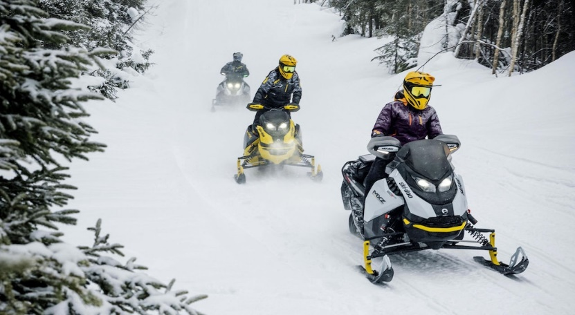

Tickets are available throughout the season at several local businesses, by calling the club house office and at all of our events.

Or, you can print out this form, complete the following and mail it along with your check to the address below.

Thank you for your support.

Name: ________________________________________

Address: ______________________________________

______________________________________

______________________________________

Phone #: ______________________________________

Please send me ______ticket(s) at $20 each. Total enclosed: ________

**Pittsburg Ridge Runners Snowmobile Club**

**17 Dickson Lane, Pittsburg, NH 03592 603-538-1142** [**www.pittsburgridgerunners.org**](http://www.pittsburgridgerunners.org)